###### CHAPTER 1

###### INTRODUCTION

**1.1 Introduction**

Online Department Management System is a web-based project developed using WordPress. It provides an online platform where all students, parents and teachers can have complete information about the college, Department of Information Science and Engineering and its events. The online department management system is to automate all functionalities of a college and department. Using this system, you can manage all department work like mentoring and alumni. Using this department management system, you can view and information about students, staff, meetings. This system helps in managing the activity of mentoring. The online department management system can be used to store information about mentoring. Using this system, you can manage all information of all aspects of the department of information science and engineering, its students, faculties, meetings and other curricular activities. Online Department Management System can store and manage all data of   the department mentoring. Using this system user can retrieve any information related to student.

**1.2 Objectives**

This is a web-oriented application allows us to access the whole information about the college, staffs, students, etc. Here we will get the latest information about the students, staffs etc.

**1.3 Scope of the project**

* College information: Through this service one can access the complete information about the college campus such as courses available, college events, achievements, management, principal, department etc.
* Mentoring: This project is about mentoring of the department of information science and engineering.

# CHAPTER 2

## SYSTEM ANALYSIS

### 2.1 Existing System

In the existing system, there is a lot of paper work, it is very time consuming and uneconomical as most of the works include manual processing. While writing a paper records the management have to keep the records very carefully as the entire data is written in mentoring books. The records are difficult to store in manual system, and it requires more manual labour work, if in case the record is lost then the data managed will also be lost sometimes leads to lot of confusion and problems were arising every time. The present system works in ASP.Net; it is HTML based static website. The static website only displays department information such as about department, contact details, faculties, achievements and gallery.

The static web site of department does not maintain the information regarding details. There is no provision of dynamic management of mentoring and alumni. To overcome these drawbacks this online department management system with mentoring and alumni was proposed.

### 2.2 Proposed System

The proposed system allows acceptance of details of each students and mentors to store it in a database. A proposed system helps in viewing in a user-friendly manner. Separate options have been given for each of the options presented on the screen. These are specific and easy to understand. Being a web-based project, this proposed Online Department Management Project is a dynamic website which is very easy to understand. With easy interface, anyone can easily work in the website. The website provides all details of the department including parents feedback, student details, proctor details and also the alumni details. The Department Management System web project like this eradicates the need to perform paper works to maintain mentoring details. With this system, mentoring details and feedback of parents will be entered using online form.

### 2.3 Objectives of Proposed System

1. To reduce the paper work
2. To reduce complexity error
3. Avoid redundancy
4. Giving accurate information
5. User friendly
6. Enables to view large volume of data in short time
7. Providing the online interface for students, faculty etc.
8. Increasing the efficiency of department record management.
9. To make the system more secure.
10. Decrease time spent on non-value-added tasks.

# 

# CHAPTER 3

## SYSTEM REQUIREMENT SPECIFICATION

The software and hardware requirements are very important to be generally required to the system and work is being done in accordance to the matter for designing a particular computer architecture, the power of central processing unit is a fundamental requirement for the computer, to be used in a very alternatively manner it’s important to work in an orderly manner that can be generally categorized and worked with increasing demand for high processing power and resources of attest versions with increasing over a period of time.

### 3.1 Hardware Requirements

### Operating System : Windows XP

### Front End : Wordpress

### Web server : XAMPP server

### Browser : Internet Explorer

**3.2 Software Requirements**

* Processor : Intel Core i3
* Speed : 2.0 GHZ
* RAM : 8 GB
* Key Board : Normal
* Mouse : Normal

###### CHAPTER 4

###### SYSTEM DESIGN

**4.1 Server Description**

###### 4.1.1 XAMPP

XAMPP  is a [free and open-source](https://en.wikipedia.org/wiki/Free_and_open-source) [cross-platform](https://en.wikipedia.org/wiki/Cross-platform) [web server](https://en.wikipedia.org/wiki/Web_server) [solution stack](https://en.wikipedia.org/wiki/Solution_stack) package developed by Apache Friends, consisting mainly of the  [Apache HTTP Server](https://en.wikipedia.org/wiki/Apache_HTTP_Server), [MariaDB](https://en.wikipedia.org/wiki/MariaDB) [database](https://en.wikipedia.org/wiki/Database) and  [interpreters](https://en.wikipedia.org/wiki/Interpreter_(computing)) for scripts written in the [PHP](https://en.wikipedia.org/wiki/PHP) and [Perl](https://en.wikipedia.org/wiki/Perl) [programming languages](https://en.wikipedia.org/wiki/Programming_language). Since most actual web server deployments use the same components as XAMPP, it makes transitioning from a local test server to a live server possible.

XAMPP's ease of deployment means a [WAMP](https://en.wikipedia.org/wiki/WAMP) or [LAMP](https://en.wikipedia.org/wiki/LAMP_(software_bundle)) stack can be installed quickly and simply on an operating system by a developer, with the advantage that common add-in applications such as [WordPress](https://en.wikipedia.org/wiki/WordPress) and [Joomla!](https://en.wikipedia.org/wiki/Joomla!) can also be installed with similar ease using [Bitnami](https://en.wikipedia.org/wiki/Bitnami" \o "Bitnami). Though it is a heavy app for most of the operating systems even when owing to its less size it takes a load on the processor speed.



Fig 4.1 XAMPP Icon

The most obvious characteristic of XAMPP is the ease at which a [WAMP](https://en.wikipedia.org/wiki/WAMP) webserver stack can be deployed and instantiated. Later some common packaged applications that could be easily installed were provided by [Bitnami](https://en.wikipedia.org/wiki/Bitnami" \o "Bitnami).

Officially, XAMPP's designers intended it for use only as a development tool, to allow website designers and programmers to test their work on their own computers without any access to the Internet.

The full form of XAMPP is X stands for Cross-platform, (A) Apache server, (M) MariaDB, (P) PHP and (P) Perl. The Cross-platform usually means that it can run on any computer with any operating system.

Next MariaDB is the most famous database server and it is developed by the MYSQL team. PHP usually provides a space for web development. PHP is a server-side scripting language. And the last Perl is a programming language and is used to develop a web application.

To make this as easy as possible, many important security features are disabled by default. XAMPP has the ability to serve web pages on the [World Wide Web](https://en.wikipedia.org/wiki/World_Wide_Web). A special tool is provided to [password-protect](https://en.wikipedia.org/wiki/Password) the most important parts of the package. XAMPP also provides support for creating and manipulating databases in [MariaDB](https://en.wikipedia.org/wiki/MariaDB) and [SQLite](https://en.wikipedia.org/wiki/SQLite) among others. Once XAMPP is installed, it is possible to treat a [localhost](https://en.wikipedia.org/wiki/Localhost) like a remote host by connecting using an [FTP](https://en.wikipedia.org/wiki/File_Transfer_Protocol) client. Using a program like [FileZilla](https://en.wikipedia.org/wiki/FileZilla) has many advantages when installing a [content management system](https://en.wikipedia.org/wiki/Content_management_system) (CMS) like [Joomla](https://en.wikipedia.org/wiki/Joomla) or [WordPress](https://en.wikipedia.org/wiki/WordPress). It is also possible to connect to localhost via FTP with an [HTML editor](https://en.wikipedia.org/wiki/HTML_editor).

**4.1.1.1 Tools of XAMPP server**

XAMPP contains tools such as Apache, MYSQL, PHP, and Perl. We will see these tools.

* [**Apache**](https://httpd.apache.org/)
* Apache server is open-source free software that is initially developed by a group of software developers and now it is maintained by Apache software foundation. Apache HTTP is a remote server(computer) if someone requests files, images, or documents using their browser they will serve those files to clients using HTTP servers. Mainly hosting companies use this application to create a VPS server and shared hosting for their clients.
* If you plan to move your testing website to web hosting, we recommend FastComet Cloud Hosting because they provide you the best service compared to other big companies. We have an Exclusive 50% Offer on [Liquidweb Coupon](https://lwebcoupons.com/) for our WPBlogX visitors.
  + [**MYSQL**](https://www.mysql.com/)
* MYSQL is open-source software. It is actually a relational database management system(RDBMS). This SQL stands for Structured Query Language. It is the most popular and best RDBMS used for developing a variety of web-based software applications. With the help of MYSQL, it is possible to organize the information, manage, retrieve, and update the data whenever you wish to do it.
* [**PHP**](https://php.net/)
* The full form of PHP is Hypertext Pre-processor. It is a server-side scripting language that helps you to create dynamic websites. This language is mainly used to build web-based software applications. It is open-source software and works fine with MYSQL. What actually happens is, the PHP code will be executed on the server and at the browser side its HTML code will be displayed.

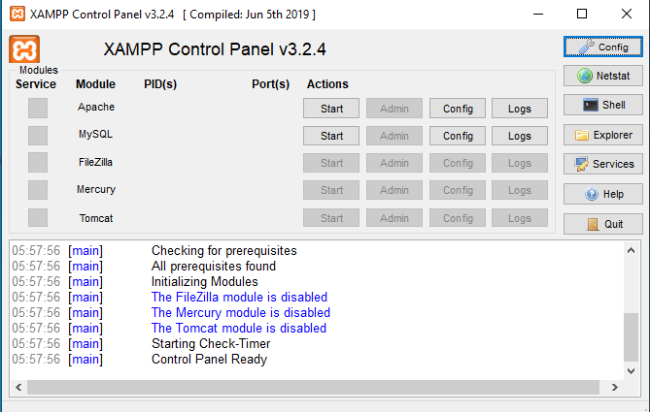

Fig 4.2 XAMPP Server

**4.1.1.2 XAMPP Control Panel**

In the control panel, you will be able to control individual components of your text server. The control panel contains various buttons like config, net stat, shell, explorer, services, help, quit.

**Config**→ It allows you to configure the XAMPP as well as the individual components

**Netstat**→ Helps you to show all the current running process on the local system

**Explorer**→ It will open the XAMPP folder in windows explorer

**Services**→ Help to show all the services that are currently running in the back-end

**Help** → As the name implies it gives you links to the user forums

**Quit** → By clicking the button the XAMPP control panel will exit

**4.2 Software Interface Description**

###### 4.2.1 WordPress

**WordPress** is a piece of [software](https://simple.wikipedia.org/wiki/Software) which has become the most widely used content management system and is used for setting up [blogs](https://simple.wikipedia.org/wiki/Blog). It is [open source](https://simple.wikipedia.org/wiki/Open_source), licensed under the [GPL](https://simple.wikipedia.org/wiki/GPL), and written in [PHP](https://simple.wikipedia.org/wiki/PHP).

WordPress is software designed for everyone, emphasizing accessibility, performance, security, and ease of use. We believe great software should work with minimum set up, so you can focus on sharing your story, product, or services freely.



Fig 4.3 Wordpress

The basic WordPress software is simple and predictable so you can easily get started. It also offers powerful features for growth and success. WordPress is web publishing software you can **use** to create a beautiful website or blog. It just may be the easiest and most flexible blogging and website content management system (CMS) for beginners.

To function, WordPress has to be installed on a [web server](https://en.wikipedia.org/wiki/Web_server), either part of an [Internet hosting service](https://en.wikipedia.org/wiki/Internet_hosting_service) like [WordPress.com](https://en.wikipedia.org/wiki/WordPress.com) or a computer running the software package WordPress.org in order to serve as a [network host](https://en.wikipedia.org/wiki/Host_(network)) in its own right. A local computer may be used for single-user testing and learning purposes.

**4.2.1.1 Advantages of WordPress**

* **Simplicity:** WordPress allows you to publish and build your website content quickly. Even as a beginner, you can easily use WordPress.
* **The cost is free** – The actual WordPress software available on WordPress.org is free to download and use. You will, however, need to pay for web hosting and a domain name.
* **Flexibility:** WordPress allows you to create many types of websites from personal blogs and online stores to online magazines and newspapers.
* **Easy to use** – If you can use a word processing software like Microsoft Word, you can use WordPress to build and manage a website.
* **Open-source software** – WordPress is open-source software that is licensed under the [GNU General Public License (GPL)](https://wordpress.org/about/license/), meaning it isn’t owned by a single company or entity. Hundreds of developers and users collaborate and contribute to the software to make it better. The spirit of open-source means constant improvements, accountability and free usage for everyone.
* **No need to know code** – WordPress removes the requirement of needing to know how to code in order to build a website. While WorSSdPress utilizes a variety of coding languages, there’s no need to know any of them to use WordPress.
* **Extendable with WordPress plugins** – The core WordPress software can be extended with WordPress plugins. WordPress plugins are bits of software that you can upload to your website to add more features (such as e-commerce, SEO, backups, contact forms and more). There are thousands of free WordPress plugins available on the WordPress.org plugin directory and a thriving premium (paid) plugins industry.
* **Highly customizable with WordPress themes** – WordPress themes provide the design and layout of your website. With a click of a button, you can change the entire look of your website by applying a new WordPress theme. More advanced WordPress themes are more like WordPress page builders, giving you even more control of your layouts.
* **Website security** – While no website platform is 100% secure, WordPress security continues to improve with a vigilant security team of core developers and users. Common WordPress security issues are usually due to user error, rather than the software itself.
* **A thriving community of users and developers** – When you have a WordPress website, you can also get involved in the greater WordPress community through your local [WordPress Meetup](https://www.meetup.com/topics/wordpress/), [WordCamps](https://central.wordcamp.org/" \t "_blank) and more. The WordPress community has a reputation of being incredibly welcoming, helpful and innovative.
* **A premium plugin and theme industry** – While there are loads of free plugins and themes, most serious WordPress website owners invest in premium (paid) plugins or themes. Why? Your purchase of a reputable premium plugin or theme helps pay for the ongoing development and support of the plugin or theme, including new features, security patches and more.

**4.2.1.2 Basics of WordPress**

* [Your WordPress Login](https://ithemes.com/tutorials/wordpress-login/) – Once WordPress has been installed on your web server, you can access your WordPress login page from two different URLs.
* [Exploring the WordPress Dashboard](https://ithemes.com/tutorials/wordpress-dashboard/) – The WordPress Dashboard allows you to control all of the behind-the-scene details of managing your site. Once you find your way around the dashboard, you’ll realize it’s really easy to use and navigate.
* [Using the WordPress Admin Bar](https://ithemes.com/tutorials/the-wordpress-admin-bar/) – the WordPress Admin Bar or toolbar. The WordPress Admin Bar is a shortcut area that allows you to access the behind the scenes controls when you’re on the front-end of your WordPress blog or website.
* [Exploring WordPress Settings](https://ithemes.com/tutorials/exploring-wordpress-settings/) – WordPress offers a ton of settings for customizing how your website functions. In this tutorial, we cover WordPress Settings in depth.
* [WordPress Posts vs Pages](https://ithemes.com/tutorials/wordpress-posts-vs-pages/) – When it comes to creating content for your WordPress site, you have the option to choose between creating either a post or page. Both have their respective uses and can add very dynamic elements to your site.
* [Creating a WordPress Post](https://ithemes.com/tutorials/creating-a-wordpress-post/) – This tutorial covers how to add your first WordPress post.
* [Adding Links in WordPress](https://ithemes.com/tutorials/adding-links-in-wordpress/) – The WordPress post and page editor makes it easy to add hyperlinks to other web pages from your content. This tutorial covers how to add links in your content.
* [Adding Images in WordPress](https://ithemes.com/tutorials/adding-images-in-wordpress/) – Using a visual element like an image or photo is a great way to spruce up your post or page content. Learn how easy it is to add images in WordPress.
* [Using the WordPress Media Library](https://ithemes.com/tutorials/using-the-wordpress-media-library/) – In this tutorial, we walk through using the WordPress Media Library. The WordPress Media Library contains all the files you’ve uploaded to your WordPress site, with the most recent uploads listed first.
* [Formatting WordPress Posts](https://ithemes.com/tutorials/formatting-wordpress-posts/) – In this tutorial, we cover some of the basics of formatting your WordPress posts with the built-in WordPress post editor.
* [Scheduling WordPress Posts](https://ithemes.com/tutorials/scheduling-wordpress-posts/) – Scheduling WordPress posts is an easy way to control when your content is published. In this video, we show you how to use the built-in WordPress post scheduler to add a time to publish.
* [WordPress Categories & Tags](https://ithemes.com/tutorials/using-wordpress-categories-and-tags/) – WordPress categories and tags are a way to add an organizational structure to your WordPress posts. This tutorial covers how to use categories and tags.
* [Creating a WordPress Page](https://ithemes.com/tutorials/creating-wordpress-page/) – Creating a WordPress page is very similar to creating a post. Just remember that pages are intended for static content, while posts are time-based.
* [Applying a WordPress Page Template](https://ithemes.com/tutorials/applying-wordpress-page-template/) – Some WordPress themes include page templates that change the way your pages are formatted on the frontend (the visible part of your website). By using page templates, your WordPress theme can give you some flexibility for how your pages look and where certain page elements are located.
* [Creating a Custom Menu in WordPress](https://ithemes.com/tutorials/creating-custom-menu-in-wordpress/) – Not sure how to best use menus in your WordPress site? In this short video, we share some tips and tricks to get your site navigation up and running in no time.
* [Managing Comments in WordPress](https://ithemes.com/tutorials/managing-comments-in-wordpress/) – Comments add a more interactive discussion element to your website, allowing visitors to comment on posts or pages. This video shows you how to manage comments on your website.
* [Creating Users in WordPress](https://ithemes.com/tutorials/creating-users-in-wordpress/) – Creating users in WordPress allows you to add users with different roles and access privileges to your site. Once created, a user will be able to log in to your site with a username and password.

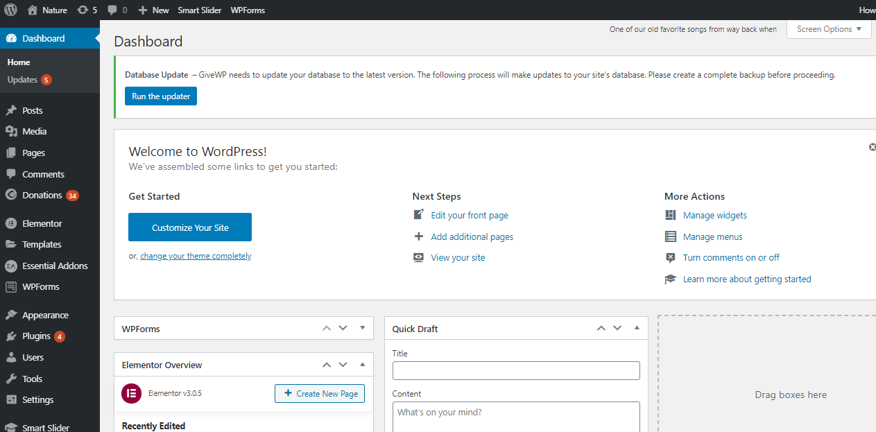

Fig 4.4 Wordpress Dashboard

**4.2.1.3 Features**

* **SEO** – Search Engine Optimization (SEO) begins at a technical level and WordPress delivers an exceptional code base for SEO. SEO allows your website’s content to be found via common search engines such as Google or Bing. Check out these [free WordPress SEO](https://ithemes.com/free-seo-training/) training videos to learn more.
* **Speed**– WordPress is a lean website framework that is constantly striving to remove code “bloat” that slows down the loading speed of a website.
* **Mobile-friendly** – Most WordPress themes are now mobile-friendly or responsive out-of-the-box.
* **Media file library** – WordPress includes a built-in media library where you can upload and embed media files such as images or videos into your pages or posts. You can even perform basic edits to your images within WordPress.
* **Easy-to-use user interface**– WordPress is very easy to use with no complicated settings. If you can use a WordPress processor, you can use WordPress. WordPress also has a focus on accessibility.
* **Custom menus** – WordPress makes it easy to create navigation menus with links to your pages or custom links.
* **Built-in blog** – Adding a blog to your website is as simple as publishing a post.
* **New in WordPress 5.0: The WordPress Block Editor** – WordPress 5.0 introduced the new Block Editor, also known as the [Gutenberg WordPress Editor](https://ithemes.com/gutenberg-wordpress-editor-10-things-to-know/). The new editor transforms the way you edit WordPress pages and posts. Now you can design and arrange your content with a more flexible “drag and drop” approach.

**4.2.1.4 Examples**

* Blog – A blog is a special type of website devoted to sharing thoughts, photos, reviews, tutorials, recipes and so much more. Blogs usually display the most recently-published content first.
* E-commerce website – An e-commerce website allows you to sell goods or services online and collect payment via an online payment system. You can download and install a WordPress e-commerce plugin to extend the default functionality of WordPress so you can have an online store on your website.
* Business website – Many businesses will benefit from having an online presence in the form of their own website. If your business needs a website for customers to learn about your company and what you have to offer, WordPress is an excellent option. Customers can contact you, ask for a quote, schedule an appointment and much more.
* Membership website – A membership website allows you to put content behind a paywall or an account login. To access pages or posts, users must login or pay for the content. WordPress can also handle membership websites with additional plugins.
* Portfolio website – Show off your artwork, design skills and more with a portfolio website built on WordPress.
* Forum website – A forum website can be a helpful place for users to ask questions or share advice. Believe it or not, many forum websites run on WordPress.
* Event website – Hosting an event? WordPress makes it easy for you to share your event details and sell tickets.
* E-learning website – Students can take online courses, track their progress, download resources and much more from an e-learning website. With a special kind of plugin called a WordPress LMS plugin, you can offer online courses from a WordPress website.
* Wedding website – Share the details of your big day with a wedding website built on WordPress. With an array of WordPress wedding themes, you can get a website up quickly and easily.

###### 4.2.2 Elementor

###### Elementor is the ultimate & free WordPress page builder, that lets you create beautiful WordPress websites in the easiest and quickest way possible. The key difference is that you can reach a high level of design, while designing live, and on the frontend of your site.

###### Elementor is the first, and currently the only frontend page builder to offer limitless design possibilities. It includes dozens of useful widgets, a stunningly designed template library, a unique mobile editing toolset and a visual revision history feature. These are actually just some of the features available for you in this free plugin.



Fig 4.5 Elementor

Elementor is the first, and currently the only frontend page builder to offer limitless design possibilities. It includes dozens of useful widgets, a stunningly designed template library, a unique mobile editing toolset and a visual revision history feature. These are actually just some of the features available for you in this free plugin. The key difference is that you can reach a high level of design, while designing live, and on the frontend of your site.

Elementor is a page builder plugin that replaces the basic WordPress editor with a live frontend editor, so you can create complex layouts visually, and design your website live, without having to switch between the editor and the preview mode. The page builder enables you to reach a top-notch quality of design without needing to use code or CSS, and without relying on developers for help.

The user interface is extremely friendly, so it only takes a few minutes to get the hang of it. We’ve built Elementor with the latest technology, and have kept updating it steadily ′, so the whole page builder is optimized and fast responsing. This means, for example, that when you drag and drop widgets, it is done instantly, without any lag time at all.

Elementor templates as additions to WordPress themes. They help you build pages quickly and easily. Basically, an Elementor template provides you with a designed, pre-built page outline that you just need to insert and fill with your content. There are all kinds of pages in the Elementor Template Library – archive pages, home, contact, about us, etc. So, when using templates, the only thing to do is pick a design you like, import it, and replace text and images with your own to end up with a high-quality page in a flash.

Templates are there to simplify the process of building your website. However, they won’t affect anything outside the page, meaning that areas like your header and footer will remain unaffected, as well as other widget areas on your site. In fact, those will follow your global theme settings, as always. This is why we said earlier that Elementor templates are additions to themes – they cannot replace a theme and you DO need a theme in order to be able to use them.

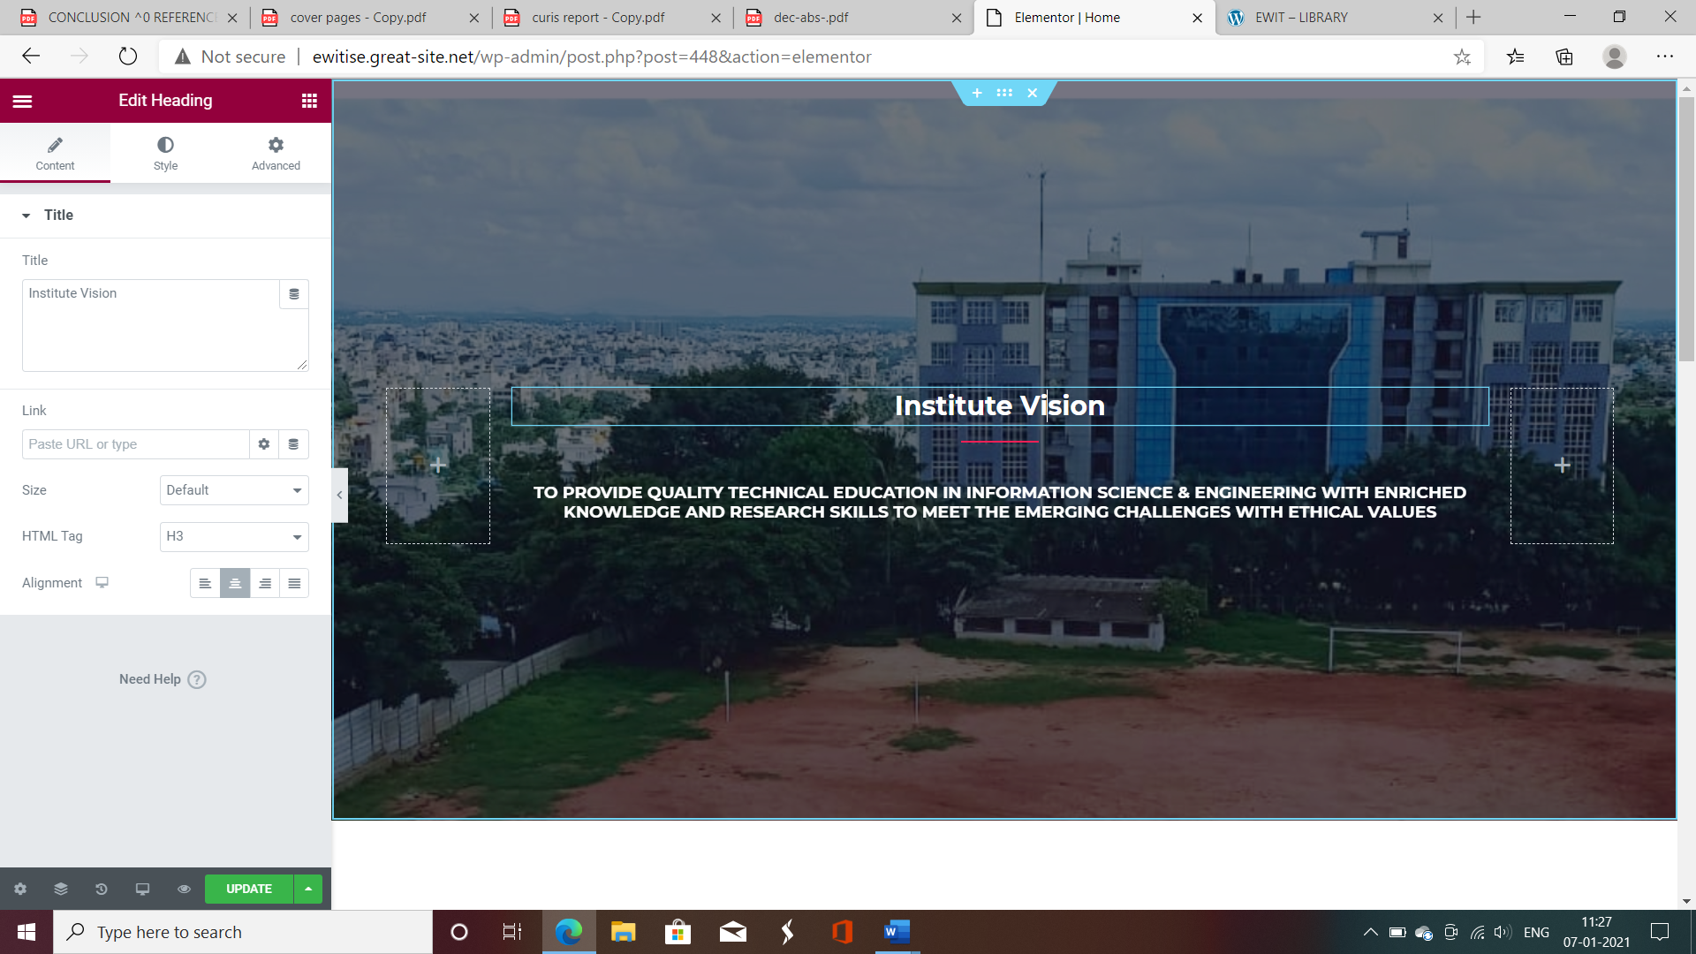Fig 4.6 Elementor Editor

This is a really neat option that Elementor affords all its users. **It lets you save a template of a whole page or just save a section**. You might wonder why you would need to save section building blocks when there are entire pages ready-made. Well, much like pages, the pre-designed blocks are formed to speed up and ease your page-building efforts. And for another, blocks are easier to insert or integrate anywhere on your website and require less stylistic harmonizing than a full page. So, depending on your preference and work methods, there are multiple options to help you with your website building.

Elementor is a page builder plug plugin that replaces the basic WordPress editor with a live frontend editor, so you can create complex layouts visually, and design your website live, without having to switch between the editor and the preview mode. The page builder enables you to reach a top-notch quality of design without needing to use code or CSS, and without relying on developers for help. Easily access and design each of your site parts – header, footer, product page and more – right within the Editor. Streamline your workflow, gain control, and enhance your results with the visual Theme Builder.

# CHAPTER 5

## IMPLEMENTATION MODULES

### 5.1 System Implementation

System implementation is the process of bringing the developed system and turning it over to user. It can be the most crucial stage in achieving a successful new system and in giving the users confidence that the new system will work and be effective.

**5.1.1 Implementation plan**

For successful implementations of the system, implementation plan is necessary. Its major elements include test plan, training plans, an equipment installation plan and a conversion plan.

The test plan provides for the preparations of the test ad for testing the system in a planned, structured manner. Training plan is necessary to ensure that all people who are associated with the computer related information system have the necessary knowledge and skills. The important activities are preparations, equipment installation and hardware –software checkout. Conversion is the process if initiating and performing all the physical operations that result directly in the turnover of the new system to the user. There are two parts of conversion. The conversion plan is implemented throughout the development phase into the operational phase. The conversion plan includes procedural conversion, program conversion and the file conversion. The changeover plan also specifies the method of change from old to new system. Choices of changeover methods include parallel operations, immediate replacement and physical changeover.

The system design specification includes input design specification and output design specification.

### 5.2 Input Design

Input design is the process of converting user-originated inputs to a computer-based formats. Input data are collected and organized into groups of similar data. Once identified, appropriate data are selected for processing the input forms are designed using GU controls. So error may be avoided. The inputs are:

### 5.3 Output Design

The output design phase is another very important one. The outputs are mainly used to communicate with user, processing the input data given by the user etc. It is documented in each stage of the project to ensure error free output. Output screens are designed in very simple and understandable format. The main output is:

1. **DISPLAY DATA:** This page is used by the User to display the data stored in the system. It helps in finding all the data stored in the System.
2. **SORT & DISPLAY ITEMS:** This page is used by the User to sort the items stored in the system based on their names. It helps in finding the information of the particular student.

**5.4 Techniques**

**Front end**: WordPress, Elementor

* WordPress: WordPress is software designed for everyone, emphasizing accessibility, performance, security, and ease of use. It just may be the easiest and most flexible blogging and website content management system (CMS) for beginners
* Elementor: Elementor is the ultimate & free WordPress page builder, that lets you create beautiful WordPress websites in the easiest and quickest way possible.

###### CHAPTER 6

**SNAPSHOTS**

**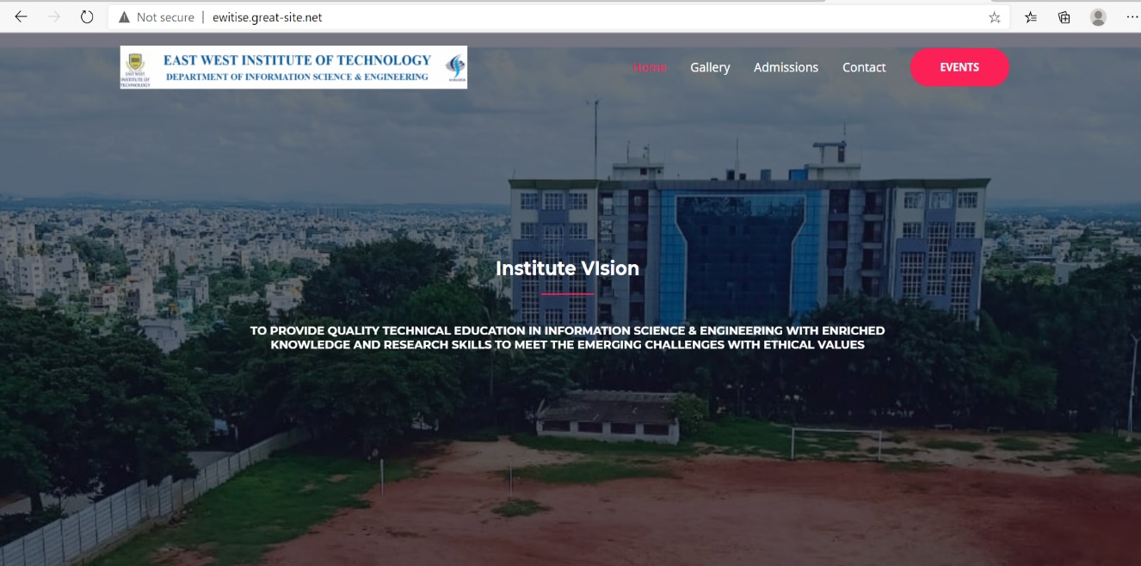**

Fig 6.1 Home Page

The website is created for the **Department of Information Science and Engineering**. **Home Page** of the website is the front page of the website. It consists of links to other pages in the website.

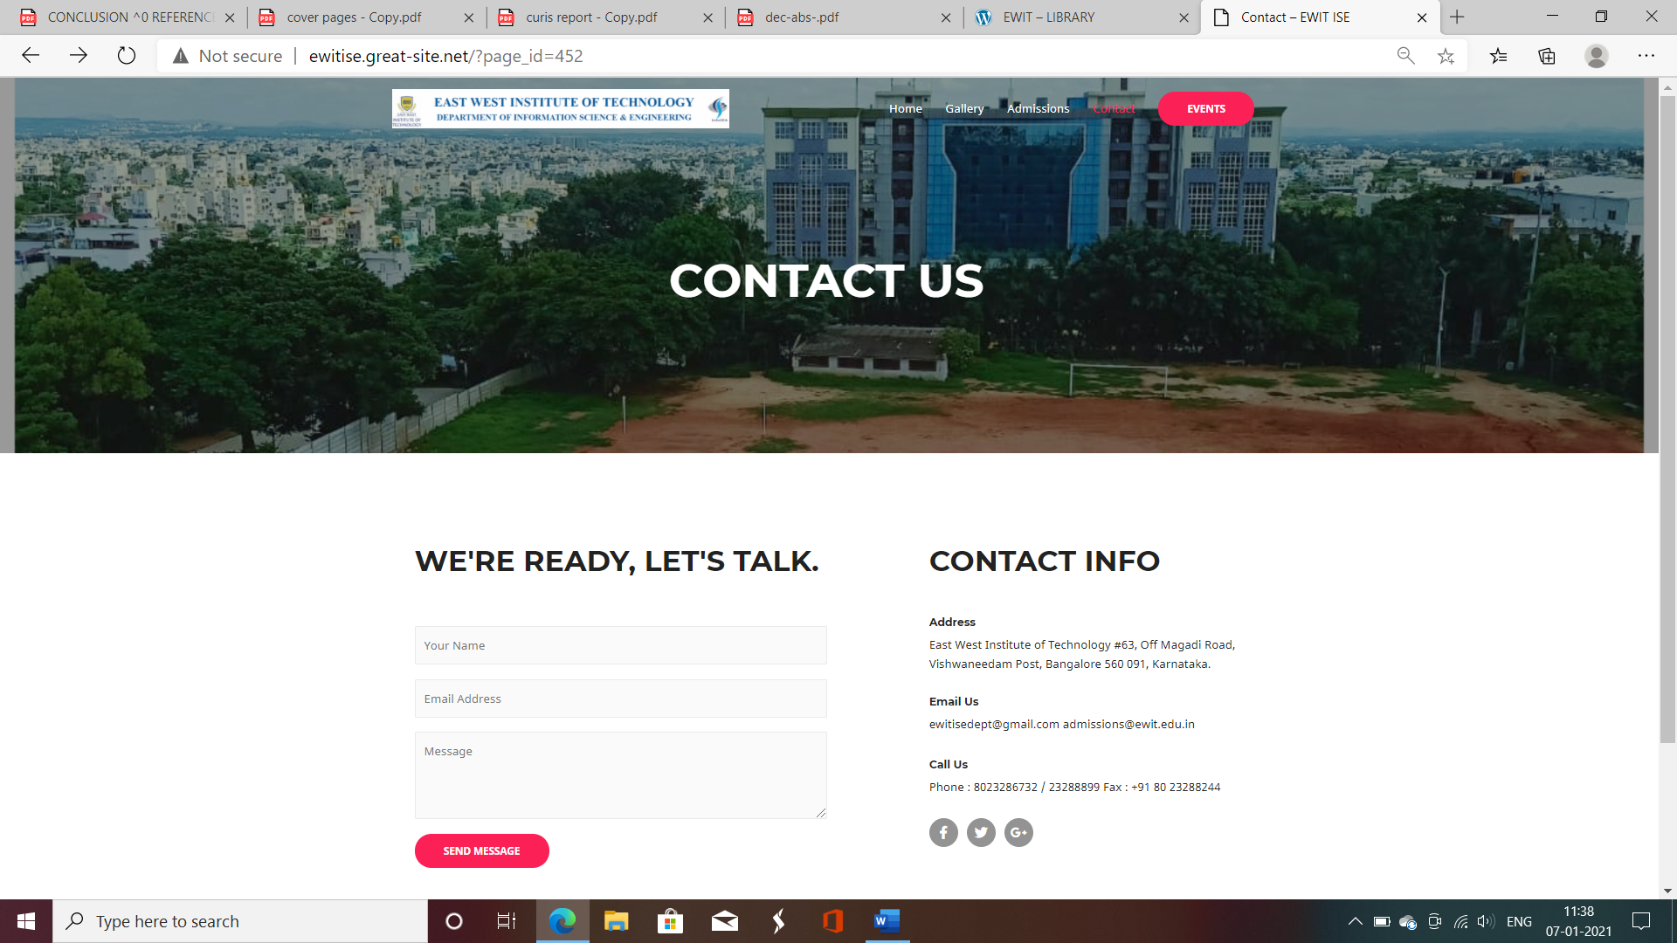

Fig 6.2 Contact Us Page link in Home Page

This page links to contact page from home page. It consists of contact details for admissions of East West Institute of Technology.

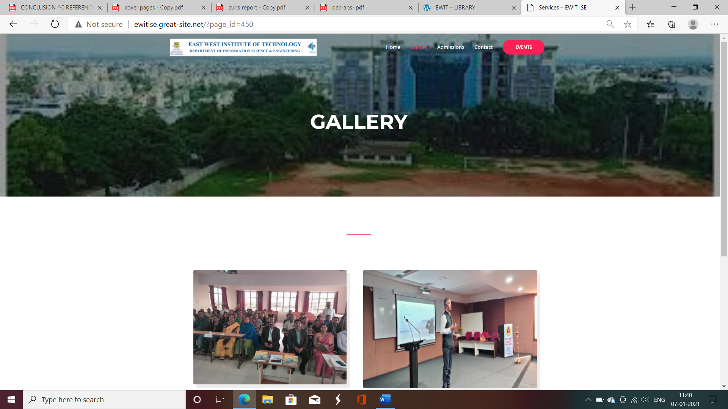

Fig 6.3 Gallery Page link in Home Page

This page links to gallery page from home page. It consists of the photos of events, mentoring, alumni etc., of East West Institute of Technology.

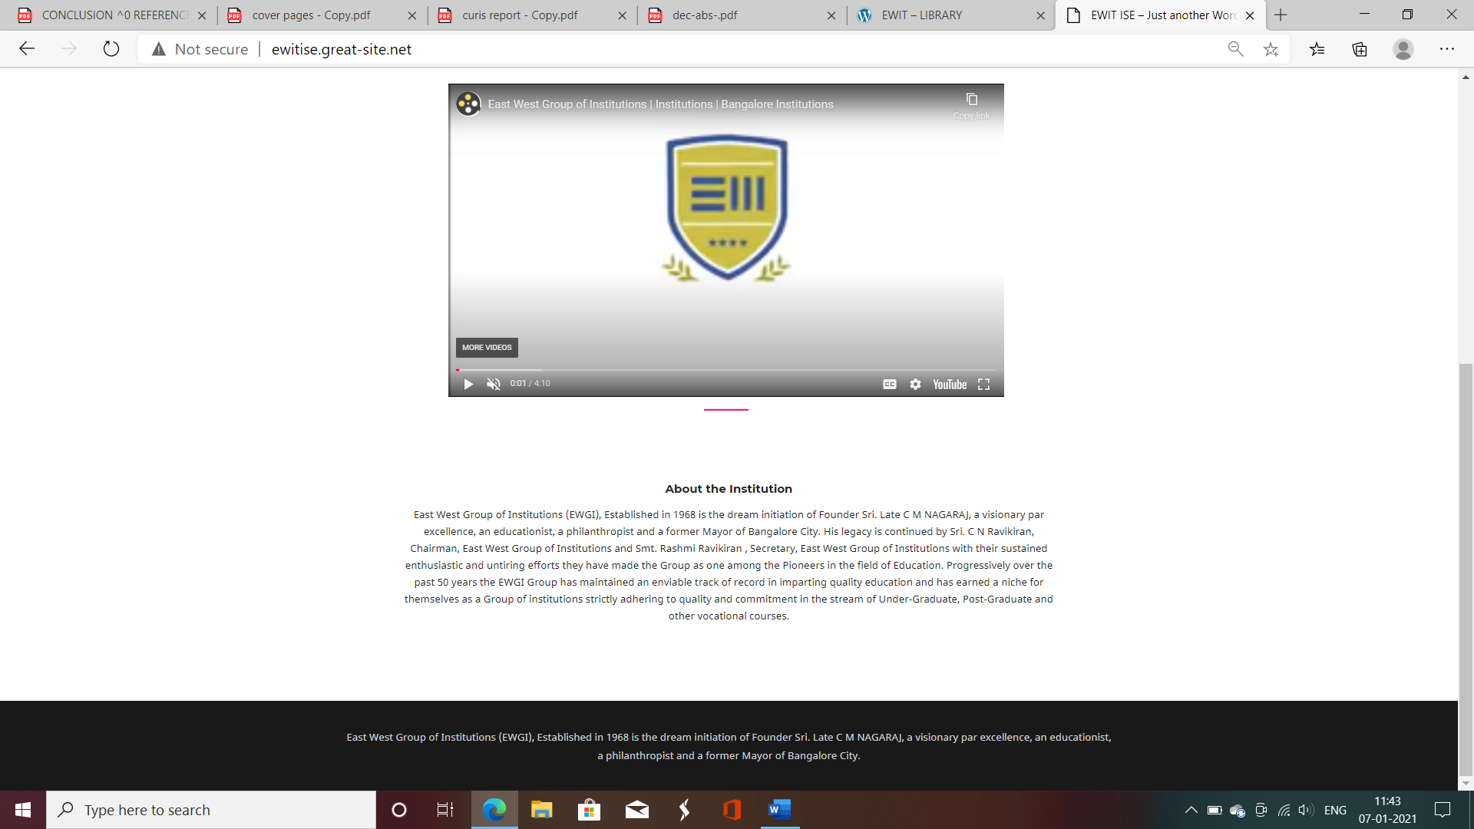

Fig 6.4 Footer Page

**Footer** Page consists of Department of ISE links to all pages of the website. It consists of contact, forms, gallery page’s links to know more about the department.

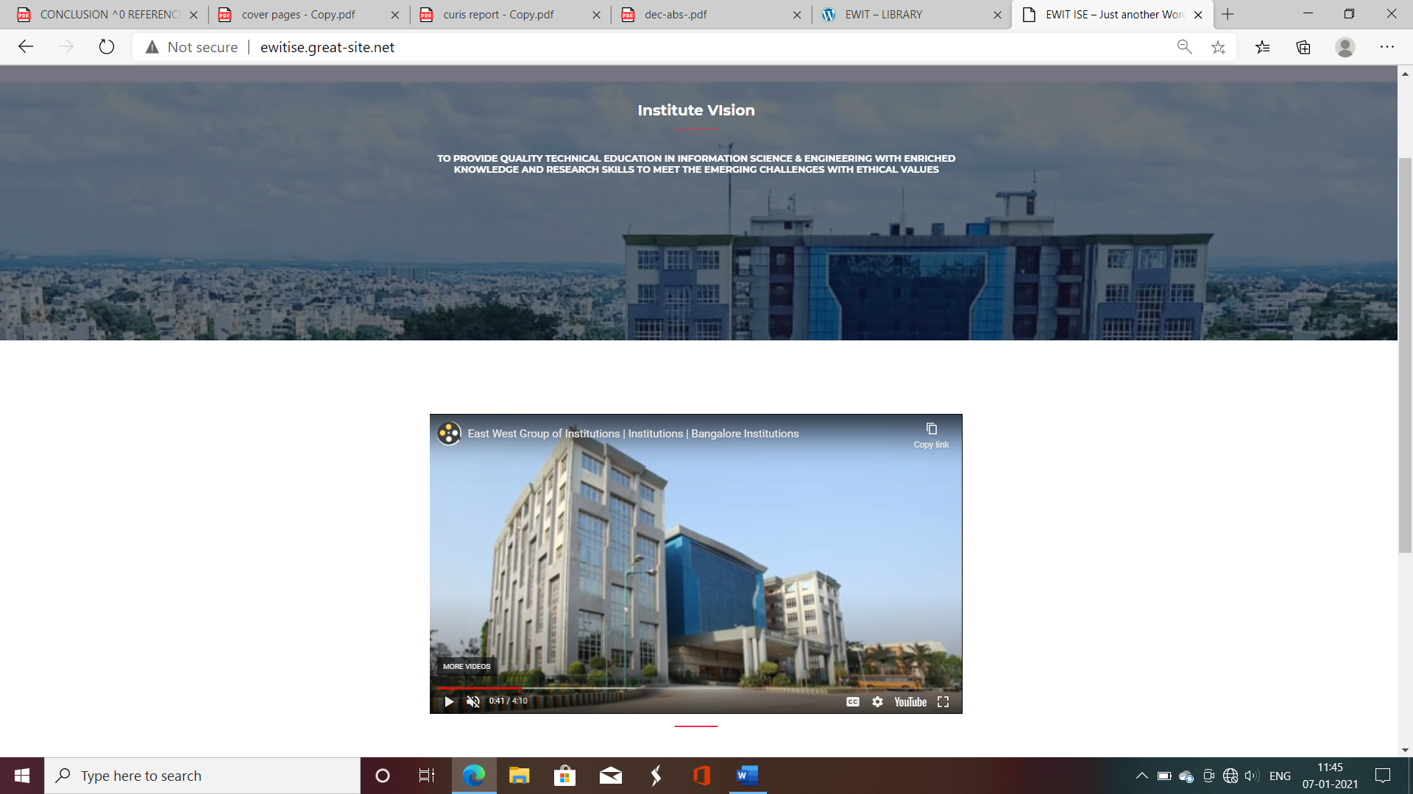

Fig 6.5 About Management Page

**About Us** Page consists of management details. It provides the information about management Founder, Chairman, Secretary and Director of East West Institute of Technology.

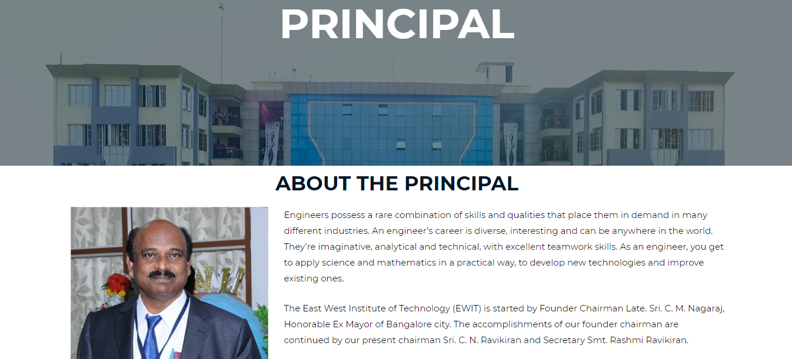

Fig 6.6 About Principal Page

**About Us** Page consists of principal details. It provides the information about the principal of the Engineering of East West Institute of Technology.



Fig 6.7 About Department Page